Drawing a Sound Creature
https://www.tate.org.uk/kids/make/art-technology/draw-sound-creature

Your challenge is to draw a creature inspired by the sounds you hear.

What does it look like? Does it sound like a big or small creature? Is it real, imaginary, or a bit of both? Where does it live? Does it have a superpower?
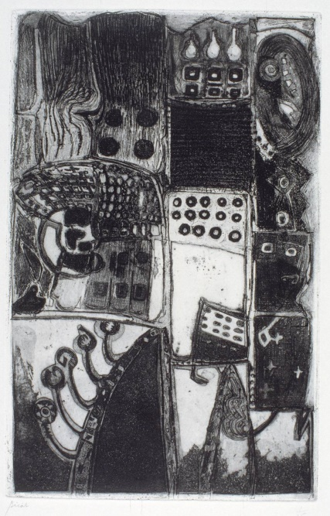
Artists have often been inspired by sounds that intrigue them or by music they love.
This is an artwork called Percussion by André Bicât. He was an artist who liked to listen to music while he made art. He made this artwork as part of a series called Rhythms of different artworks inspired by different instruments and sounds. Percussion instruments are ones where you make a sound by hitting them with your hand or a stick.

What about this work makes you think he might have been listening to beating drums while he made it?
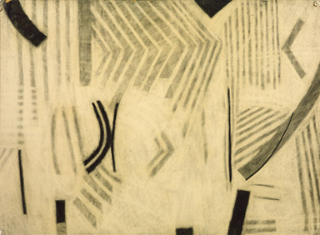
This artwork by Tom Phillips is called Music Drawing. Phillips drew while he listened to music. He wanted us to ‘read’ some of his drawings from left to right as though we were listening along to the music along witih him.

Other artists make something called sound art. This is where the sound is the art!

LET'S GET STARTED
What you need

Pens and pencils
Paper

Either listen to the sounds on the link at the start of the page or listen to some sounds around your house or outside.

Now try drawing your own sound creature. Remember be as adventurous as you like!

