Times table practice
Complete daily rockstar sheets and then spend the rest of the half an hour completing further practice either online or in your workbook:

Online (focus 6x for this half term)
Hit the button: https://www.topmarks.co.uk/maths-games/hit-the-button
TT rockstars: https://ttrockstars.com/

Paper based (focus 6x for this half term)
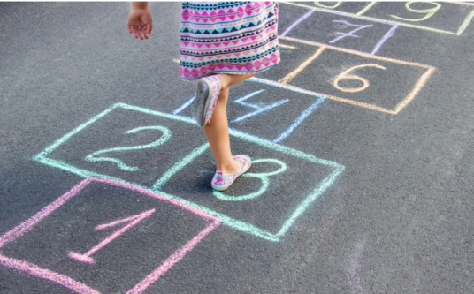
Hop scotch:
Create a hop scotch outside with chalk, but instead of writing the numbers 10, you could use the multiples of 6 – so 6,12,18,24,30,36,42,48,54 &60

Lego bricks:
If you have any Lego bricks with 6 circles on you could use them to help you become with familiar with the 6 times tables. So for 3x6, you would count the circles on 3 blocks.

Football tables:
Write random numbers from 0-12 on your ball. Then throw it into the air the number that is in the centre of the ball facing you, you will then times by 6. So if the number 4 was directly face you, you would solve 4x6.

Bottle caps:
Write different 6x tables questions on the lids from bottles and turn them over so they are facing down. Then pick one to turn over – if you answer it correctly you get to keep it turned up. If you answer incorrectly you flip it back over so you can have another go later.

