Art-Andy Warhol
In the 1960s Andy Warhol became known as one of the leading artists of the pop art movement.
Pop artists felt that art should reflect modern life and so they made art inspired by the world around them – from movies, advertising and pop music to comic books and even product packaging.
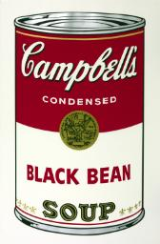
Andy Warhol
Black Bean 1968
Warhol was famous for exploring everyday and familiar objects in his work, using brands such as Coca-Cola, Brillo and Campbell’s Soup.
He liked the idea of taking ordinary things, for example cereal or bananas, and turning them into art.
He did this with his famous print of a tomato soup can. He also made a print of every type of soup that Campbell's made! Including the one above.
Have a go at designing your own soup can! It can be a real soup flavour or an imaginary one!

THINGS TO THINK ABOUT
- What ingredients will go in your soup? How does it taste?
- What will it be called?
- Should the can be bright and bold or cool and dark?
- How would it look in the supermarket?

