PE – week 1
Warm up:
https://m.youtube.com/watch?v=XRdSjabz1vc
Cool down:
https://www.youtube.com/watch?v=7gMuN6m1Gso
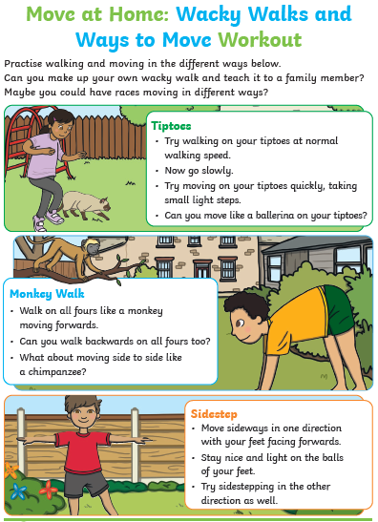
Main workout:

