Prepositions
Preposition is a word used to describe where something or someone is.
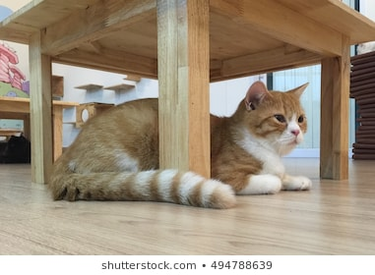
The cat is under the table.

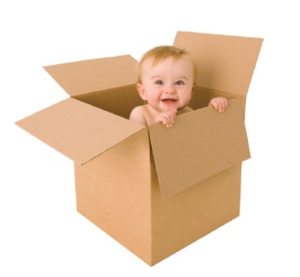
Now can you write a sentence using a preposition.

_____________________________________________________________________________

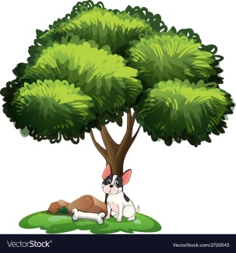

____________________________________________________________________________

______________________________________________________________________________
Write 2 sentences using a preposition
____________________________________________________________________________________________________
____________________________________________________________________________________________________

