Tuesday
Practise writing your spellings out in one of these fun ways:
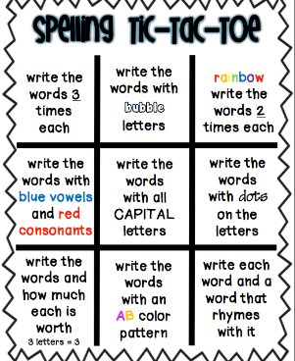
Won’t
isn't
haven't
hasn't
we’re
who’s
they’ve
could’ve
they’d
she’ll

