Week Beginning 22nd February

Thursday 25th February
Building Strong Core Muscles 15mins
Communication and Language 15 mins
Phonics 10 mins
Maths 15 mins
Building Fine Motor Skills 10 mins
Pencil Control Activity 10 mins
Understanding the World – Growing – 15 mins
Reading Activity 15 mins
Topic Based Activities 30 mins

Building Strong Muscles
This week we are going work on our balance and
core muscles. Lots of the activities work on crossing the midline which is an important skill to help with all physical activities in the future.
Thursday – Wash the window. Using some spray and cloths get your child to polish the spray until the smears have gone. A great activity to build strength. Make sure children keep safe during this activity. If you enjoy this one you could always have a go at washing a car with a sponge as there is lots of stretching to get the car clean and this will build
Communication and Language Skills

This week’s talk activities are linked to the story
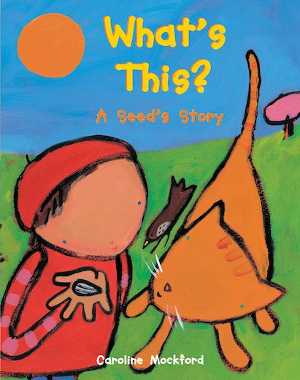
What’s This? – A seed’s story by Caroline Mockford

We have a video of this story on Class Dojo and our
Website. It is also available on YouTube.

Thursday –
Listen to the story and then see if you can sequence these events into the right order.
What is first, second, third, fourth and last?

The shoot grows in to a tall stem with lots of leaves.
A green shoot appears.
A beautiful yellow flower grows.
The bird finds a seed on the floor.
The sunflower head drops and droops.

Phonics
These sessions follow the same format as last few weeks. See links from week beginning 11th January if you would like help to understand how we teach phonics.
Every day access the phonics PowerPoint Phonics Pictures 6 (see documents) Look at the picture and learn what it is.
Recap the pictures covered to date.
Thursday – thank you said the princess.
Adult says “th” and child repeats “th”. This sound is made by the tongue coming through the teeth.
Talk about the story: The princess in the tower is rescued by the horse she says thank you.

This video helps with how to pronounce sounds: How to say the sounds
https://www.youtube.com/watch?app=desktop&v=TkXcabDUg7Q

Phonic Game
This week the game is:

Fred is deciding what to wear
Adult needs to make sure these are words your child is familiar with. You could get the clothes out so they are next to them. As confidence grows children begin to be able to orally blend words which they do not have a visual image for.

Thursday
j-ee-n-s jeans
p-a-n-t-s pants
sh-oo shoe

Maths
This week we are going to work on counting forwards and backwards using number rhymes to help us.
Thursday Today and tomorrow we are going to use the 10 in the Bed song. There is a version online here:
https://www.bbc.co.uk/teach/school-radio/nursery-rhymes-ten-in-the-bed/z7bnmfr
.
There were TEN in the bed and the little one said,
'Roll over, roll over!'
So they all rolled over and one fell out...
There were NINE in the bed and the little one said...
There were EIGHT in the bed and the little one said...
There were SEVEN in the bed and the little one said...
There were SIX in the bed and the little one said...
There were FIVE in the bed and the little one said...
There were FOUR in the bed and the little one said...
There were THREE in the bed and the little one said...
There were TWO in the bed and the little one said...
There was one in the bed and the little one said,
'Good night!'

You will need your number cards 1-10. You can use dolls or character toys to make 10 and then after each line make one fall out the bed. Talk about the number getting smaller, less and fewer.
Building Fine Motor Skills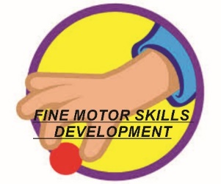
This week we are working on using utensils including a spoon, fork and knife.

Thursday – Spreading butter or cream cheese on a cracker/biscuit
Child needs to hold the cracker in one hand and the knife in the other. It takes practice to learn how to spread the butter/margarine using the flat side of the knife. Of course when you are finished you can eat it!

There is also this lovely idea below where pieces of apple are joined together to make a frog.
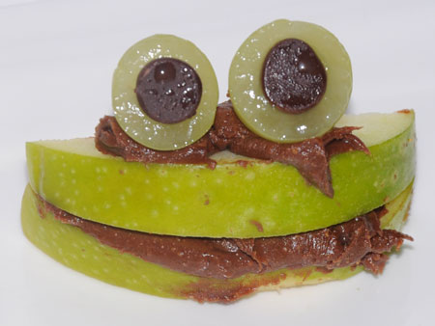

Pencil Control Skills
So many of you are enjoying our pencil control sheets so I have found some more on the growing theme for this week. There are enough to do one each day. Find these in the resources ‘Pencil Control Sheets’.

Try to hold your pencil with a comfortable hold that is not a whole fist grip. Make sure the pencil is pointing upwards not out of the side of the child’s hand.
With pencil control the more practise the better but don’t forget the fine motor activities develop the same strength (just without a pencil) so these are a great help too.

Understanding the World – Growing
Go on a growing hunt.

For this game you need to be outside. You could adapt it for things you can see from the window if you are unable to go outside.

See the next page for a sheet where you can tick off everything you find. Talk about what is alive and what is growing. I have put something on the list that is not alive or growing deliberately (the puddle!)

Reading Activity
This activity is repeated every day and is the same as all the other weeks. The booklet from the Book Trust ‘Reading with your child’ from the first week’s resources helps if you need any advice.
Share a storybook with your child. Talk about the pictures and the story. Questions like the ones used in our talk activity over the weeks are good ones to ask.

Topic Learning Thursday
Draw a picture of a magical flower garden where you can grow any flowers you like. Don’t forget to have a stem on each flower, some ground for the flowers to grow in and some fantastic, shaped petals.

