Times table practice
Complete daily rockstar sheets and then spend the rest of the half an hour completing further practice either online or in your workbook:

Online (focus on 3,4&8 times):
Hit the button: https://www.topmarks.co.uk/maths-games/hit-the-button
TT rockstars: https://ttrockstars.com/

Paper based (focus on 3,4 & 8 times):
Create a poster to hang in your bedroom
Make times tables flowers:
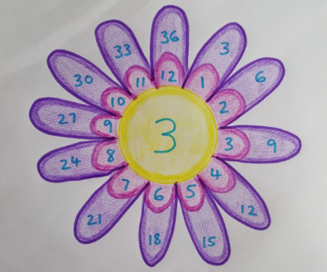

Explore patterns eg. the 4 times tables link in with the 8 times tables
Recall – practice saying them aloud eg. 1x3=3, 2x3=3
Use concrete objects eg. using pasta so show 1x3, then 2x3 etc…
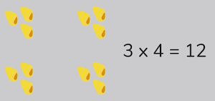

Using chalk outside

