Week Beginning 1st March

Thursday 4th March
Building Strong Core Muscles 15mins
Communication and Language 15 mins
Phonics 10 mins
Maths 15 mins
Building Fine Motor Skills 10 mins
Pencil Control Activity 10 mins
Alliteration 15 mins
Reading Activity 15 mins
Topic Based Activities 30 mins

Building Strong Muscles
This week we are going work on our balance and co-ordination again. The games are all based around using lines or marks on the floor. Just like the tightrope game you all enjoyed the other week. You could use tape, wool, string, a skipping rope etc. If the weather is fine this could be done outside with chalked lines.
Thursday
Using your four lines from Monday. Your challenge today is to stretch wide.. How wide can you go without touching the ground? How much wider can you go if you do touch the ground?

Communication and Language Skills

This week’s talk activities are linked to the story Oliver’s Vegetables by Alison Bartlett and Vivian French.
This story is the one we have videoed for you.
Also available in various formats on YouTube. I liked:
https://www.youtube.com/watch?v=2yvllKqyVUc

Thursday
Talk about your favourite parts of the story?
Why is this part your favourite?
What happens?
How many feelings words to explain why you like this part can you use?
E.g. happy, pleased, smiley, cheerful, delighted, enjoyable etc.

- Building Fine Motor Skills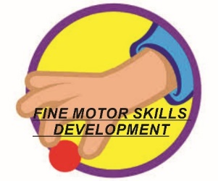
- This week we are working on building strong finger muscles through messy play. We are going to use our finger paint all week so make sure you save some for each day.
- Thursday
Use your finger paint. Your adult might like to put a little of each colour in a washable bowl so that you save some for another day.

Use your finger or fingers to make long and wavy movements. You are taking your finger on a walk all over the paper.

Phonics
These sessions follow the same format as last few weeks. See links from week beginning 11th January if you would like help to understand how we teach phonics.
Every day access the phonics PowerPoint Phonics Pictures 7 (see documents)
Thursday Recap the pictures covered to date. Including thing on a string and I think I stink.
We have covered all the pictures in Set One and soon will be thinking more about learning the phonemes (letter sounds). For the rest of this week we are going to revisit the pictures and make sure your child knows them all and can recall them quickly.
Today’s game to stick up the images in a frieze (perhaps on a wall or the floor or table will do). Ask your child to find the picture as quickly as they can. Then swap roles and your child becomes the teacher and you have to find the picture they name.

Phonic Game
This week the game is:
Fred‘s action game
Adult needs to make sure these are words your child is familiar with. If your child continues to find this tricky don’t give up! It can take months to get really confident in this game. However, we find by the end of the summer term nearly everyone can achieve this and it gives them a great start into reading and writing in Year Reception

If you are finding this tricky do the same three words every day until you achieve them. Then gradually add more in.

Thursday
- Adult: says word and child tries to copy it
- Adult: says word and child tries to copy it
3, Then child tries to blend it. If the child gets stuck adult says it again like a robot and then blends it i.e. says it

f-l-op (flop)
b-e-n-d (bend)
s-n-a-p (snap)

Maths

For the rest of this week we are going to work on how we make marks and write numbers.

Thursday

This game is using toy or real food. You need a basket or bag to put them in. Make sure there is a variety of how many of each food.
Ask your child to find all the ….
Red ones, round ones, apples, cakes, chocolates etc.
Each time count them into the bag or basket.
Then on an easel or piece of paper write down how many using numbers and marks.
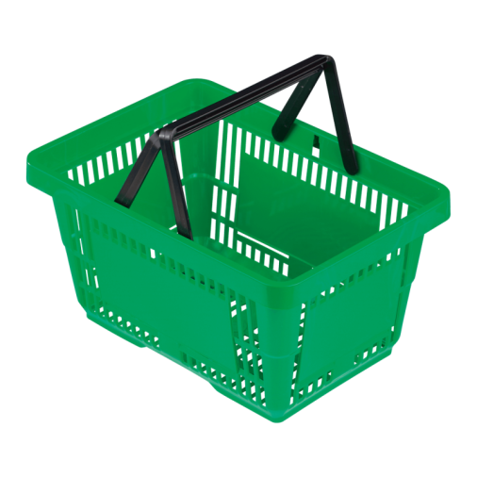
Pencil Control Skills
Try to hold your pencil with a comfortable hold that is not a whole fist grip. Make sure the pencil is pointing upwards not out of the side of the child’s hand.
With pencil control the more practise the better but don’t forget the fine motor activities develop the same strength (just without a pencil) so these are a great help too.

This week we are going to work on filling our piece of paper with different patterns to help with control

Thursday –Zigzag lines.
What will you turn these into?

Alliteration

For this learning task each day we are going to complete some more phonics work linked to the first sound or phoneme in a word. We call it alliteration when a group of words all begin with the same sound .

Thursday

Charlotte the chef is making a silly sound soup. Each soup needs three ingredients that begin with the same sound. She has made ‘t’ soup with toffees, tomatoes and toast! Can you think of three foods that she can put in the ‘s’ soup?

Topic Learning Thursday

Do you on which type of plant vegetables and fruit grow? Our Oliver’s vegetable book will help. Here is a matching game for you to do too.

