Monday
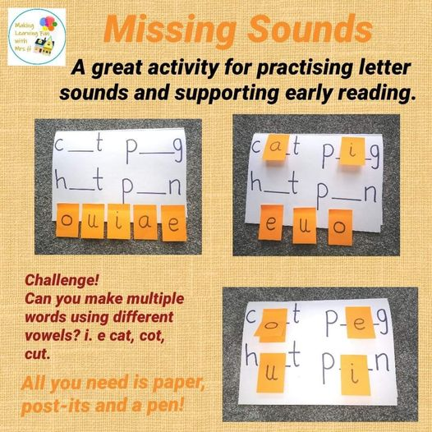
Phonics activity to replace the comprehension activity if it’s a little too tricky.

