Height
Watch this video about height.

https://www.youtube.com/watch?v=_YzACucjF38

Children use and understand the language of length such as long, longer, short, shorter, tall, taller. They need to recognise language will change depending on what type of length they are describing and comparing.
Fluency task
To be able to understand that height is a type of length.
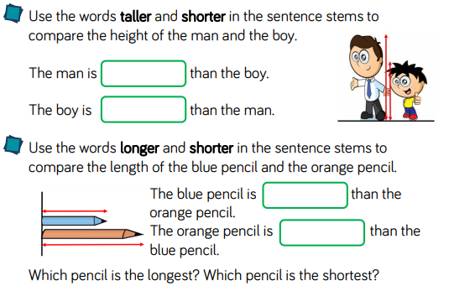
Complete the quiz on height and length.
https://www.bbc.co.uk/bitesize/articles/zf4vbdm

