Lesson 3—

• Read examples of non-fiction texts

• Identify the different the features by underlining and labelling them

Lesson 3

LO: To identify features of a non-fiction text.

There are 3 examples of non-fiction texts. You must identify (by underlining and labelling)   
the following:

• Title

• Sub-headings

• Pictures with captions

• Diagrams

• Rhetorical questions

• Formal language

• Range of sentence types

• Organised paragraphs

• Factual language (no opinions)

• Technical language/vocabulary (specific to the topic)

•

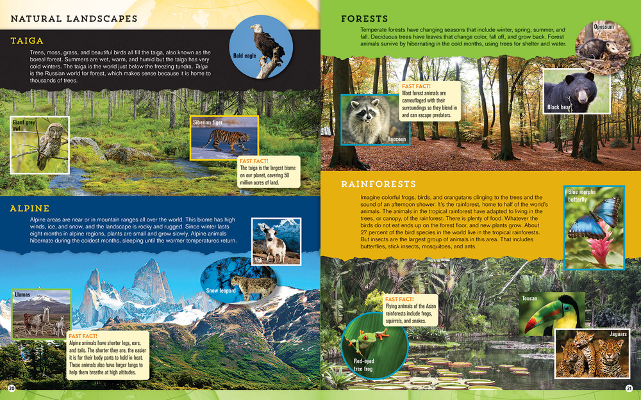

Text 1

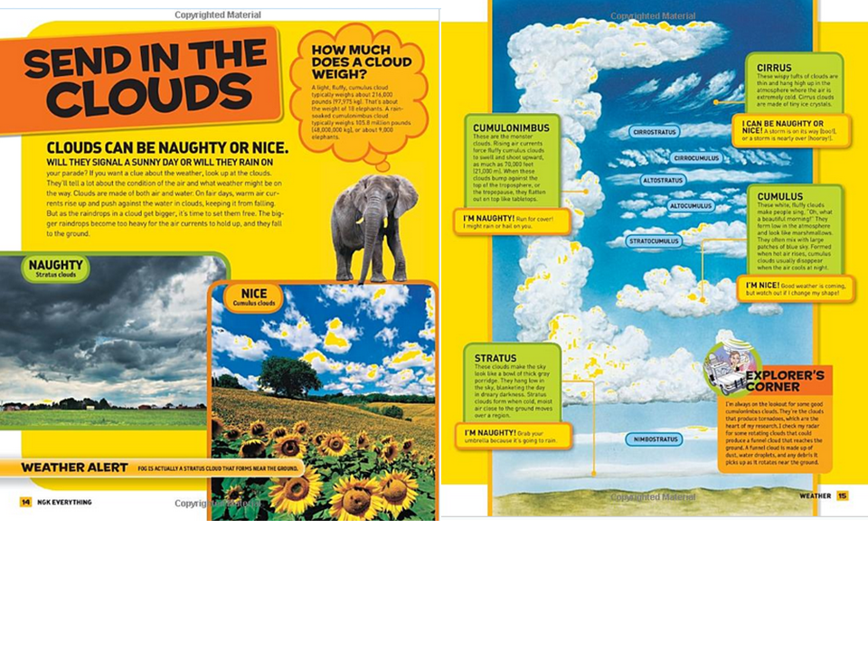

Text 2

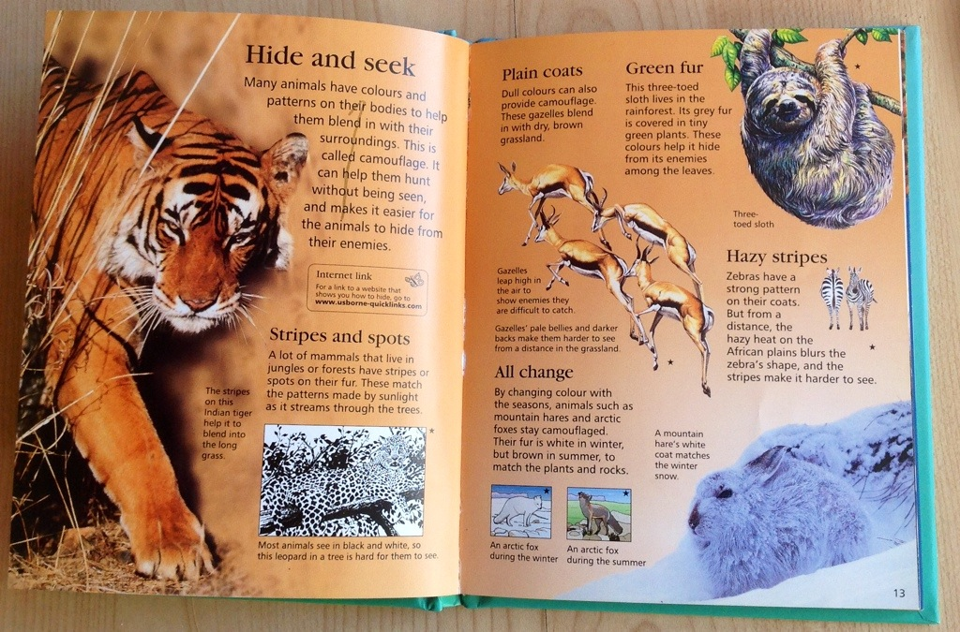

Text 3