Week Beginning 1st March

Monday 1st March
Building Strong Core Muscles 15mins
Communication and Language 15 mins
Phonics 10 mins
Maths 15 mins
Building Fine Motor Skills 10 mins
Pencil Control Activity 10 mins
Alliteration 15 mins
Reading Activity 15 mins
Topic Based Activities 30 mins

Building Strong Muscles
This week we are going work on our balance and co-ordination again. The games are all based around using lines or marks on the floor. Just like the tightrope game you all enjoyed the other week. You could use tape, wool, string, a skipping rope etc. If the weather is fine this could be done outside with chalked lines.

Monday
You need 4 lines spaced out ( you are going to use these every day this week.)
)
Jump from one line to the next with feet together and bent knees. Make yourself very springy! Carry on until you are out of puff.

Communication and Language Skills

This week’s talk activities are linked to the story Oliver’s Vegetables by Alison Bartlett and Vivian French.
This story is the one we have videoed for you.
Also available in various formats on YouTube. I liked:
https://www.youtube.com/watch?v=2yvllKqyVUc

Monday –
Listen to the story.
Talk about different vegetables and how they grow.
Talk about what you like and don’t like to eat.
Pause the video to look at the different vegetables when they are growing and when Oliver is eating them.

Building Fine Motor Skills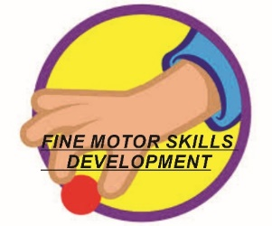
This week we are working on building strong finger muscles through messy play. I’ve seen some fantastic fingers of you all with messy materials and as I know you love it in Nursery too so this is our theme this week.
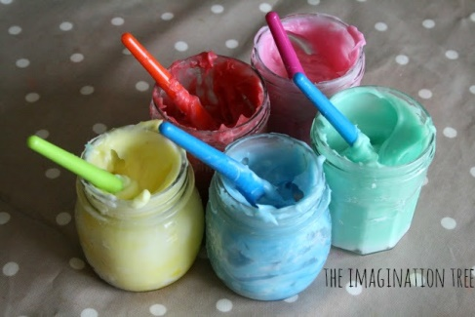
Monday You will need some finger paint. This is a thicker paint which you use with fingers and not a brush. Here is a recipe. This needs to be made by an adult as it contains boiling water.
* 2 cups of corn flour
* 1 cup of cold water
* 4.5 cups of boiling water
* Liquid food colouring
Method:
Mix the cornflour with the cold water and stir together. Pour in the boiling water and stir between each cup. It goes really strange (but keep stirring and it literally seems to “melt” into a wonderful, custard-like consistency. We then separated it into individual jam jars before adding colouring, but you can do it however you like and this is the stage to add colour.
- Once this is cool let your child play and experiment. You could just play with it on a washable tray or on paper.
- Don’t forget to save some for the rest of the week.
- Phonics
- These sessions follow the same format as last few weeks. See links from week beginning 11th January if you would like help to understand how we teach phonics.
- Every day access the phonics PowerPoint Phonics Pictures 7 (see documents)
- Monday – Recap the pictures covered to date.
- Look at the picture and learn what it is.
- Today’s picture is a cat with a toy. It is
- “thing on a string”
- Adult says “thing on a string”
- Child repeats “thing on a string”
- This seems very odd but it links to the “ng” phoneme. Just like at the end of thing, string, strong etc.

Phonic Game
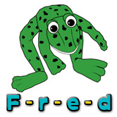
This week the game is:
Fred‘s action game
Adult needs to make sure these are words your child is familiar with. If your child continues to find this tricky don’t give up! It can take months to get really confident in this game. However, we find by the end of the summer term nearly everyone can achieve this and it gives them a great start into reading and writing in Year Reception

If you are finding this tricky do the same three words every day until you achieve them. Then gradually add more in.

Monday – Remember the adult says the word like a robot and the child repeats it. The idea is for him/her to orally blend the word to hear what the word is.
- Adult: says word and child tries to copy it
- Adult: says word and child tries to copy it
3. Then child tries to blend it. If the child gets stuck adult says it again like a robot and then blends it i.e. says it
h-o-p (hop)
j-u-m-p (jump)
r-u-n (run)

Maths
This week we are going to work on capacity for two days. Capacity is linked to how much containers will hold. Children will be comparing amounts and building up vocabulary to use.
Monday

You need two or three different size containers of the same sort e.g. a large and small bowl or a large and small bottle. The most important thing is to be able to see the difference.

Get your child to fill each container up (with water) until they are full and then empty them. Talk and compare the two.
Key Vocabulary:
Big, biggest, bigger.
Small, smallest, smaller.
Full
Empty
Overflowing

Pencil Control Skills 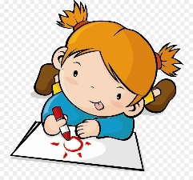
Try to hold your pencil with a comfortable hold that is not a whole fist grip. Make sure the pencil is pointing upwards not out of the side of the child’s hand.
With pencil control the more practise the better but don’t forget the fine motor activities develop the same strength (just without a pencil) so these are a great help too.

This week we are going to work on filling our piece of paper with different patterns to help with control

Monday –
Make a row of long and short lines.

Try to fill your whole page with them.

Alliteration

For this learning task each day we are going to complete some more phonics work linked to the first sound or phoneme in a word. We call it alliteration when a group of words all begin with the same sound .

Monday
Adult needs to collect a set of objects or toys from around the home which begin with the same letter.

E.g. for m
mouse, mug, Minion, money, Mickey mouse, muffin, mat, mitten, moon, mop, monkey etc.

You need about 6.

Then encourage your child to pick each one up or touch them.. Together say what it is emphasising the first letter of the word e.g. mmmmmug. Do this for all the items. Talk about how they sound the same at the start/beginning.

Reading Activity
This activity is repeated every day and is the same as all the other weeks. The booklet from the Book Trust ‘Reading with your child’ from the first week’s resources helps if you need any advice.
Share a storybook with your child. Talk about the pictures and the story. Questions like the ones used in our talk activity over the weeks are good ones to ask.

Topic Learning Monday

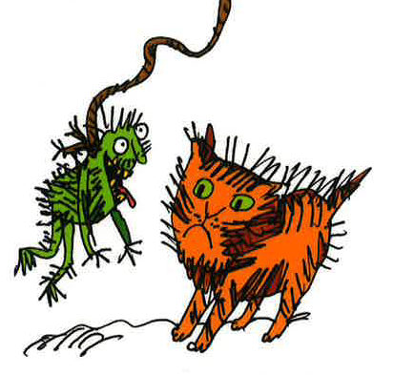
This learning links to the phonics. Make a thing on a string.
You need:

A piece of string (or wool) or elastic.
A picture or painting made on a strong piece of cardboard e.g. an empty packet of cereal.

- Draw or paint yourself a funny creature. It could be a monster or something nice!
- Make a hole in the top and tie on the string or elastic. Say “thing on a string” as you play with it.

