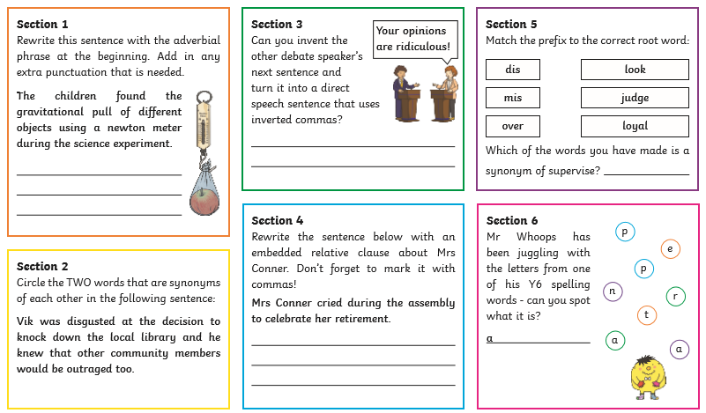

SPAG—Starter 2

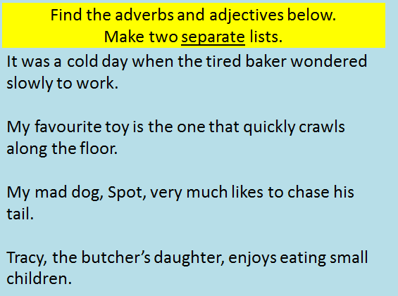

SPAG—Lesson 2—Main activity

LO: To identify adverbs and adjectives.

Copy these sentences into your book. Underline the adjectives in blue and the adverbs in red. (you may use other colours if you wish to, but make a key!)