Where do you think they are?

…………………………

Do you think anyone else is with Matisse and Violet?

…………………………

Who?……………………………………………………

Why do you think this?............................................................................................................................................................................................................................

We have been learning the skill of

inferencing - book talk

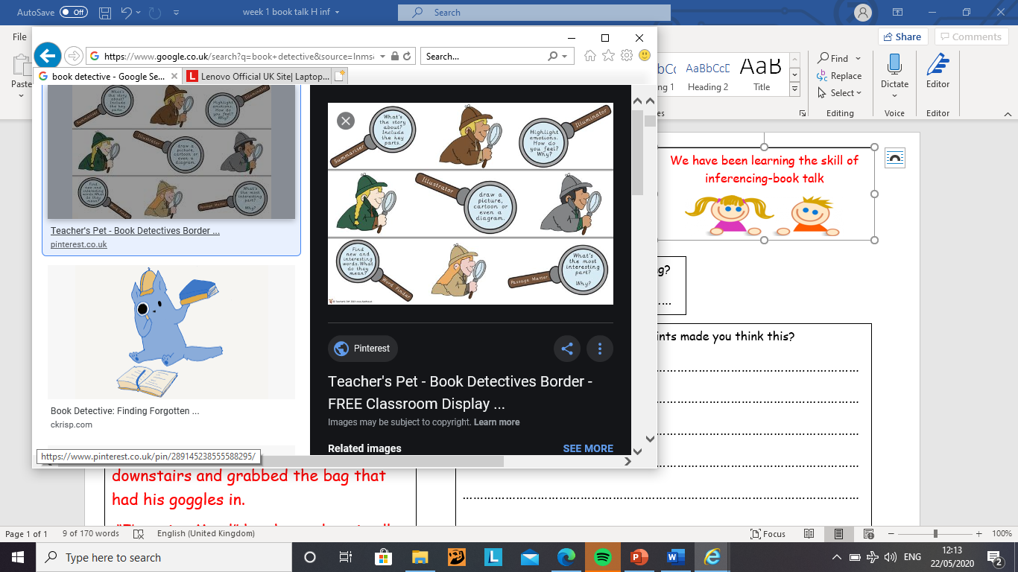

Can you think of a title for this story?

……………………………………………………………………………………………………………………………………

It was a pleasant, sunny day and Matisse pushed Violet gently on the swing. She squealed happily as it went back and forth. After a while, Matisse began to get bored. He raced off towards the biggest slide he could see. Violet struggled to get off the swing and began to toddle her way towards the slide Matisse was already zooming down. Violet had just reached the bottom of the slide when Matisse ran towards the climbing frame. “Mattie! Mattie! Wait for me,” she shouted as she tried to catch up with him. Matisse scrambled his way up the climbing frame like a monkey scaling a tree. Violet managed to reach up to the first ring but couldn’t manage to get her leg to reach. She sat down on the ground and began to cry.

I think Violet has short legs. What might have made me think this when I was reading the text?

…………………………………………………………………………………………………………………………………………………………………………………………………………………………………………………………..

What season do you think it is?

………………………

What words made you think this?

…………………………

………………………..

How do you think violet was feeling when she was on the swing?…………………………………….

……………………………………………………………………………..

What made you think this?

……………………………………………………………………………………

…………………………………………………………………………………….

……………………………………………………………………………………...

Who do you think is the oldest Matisse or Violet?

……………………………………………………………………………………..

What made you think this?

…………………………………………………………………………………………………………………………

…………………………………………………………………………………………………………………………