Watch the video: https://www.youtube.com/watch?v=yjzW11HQMY
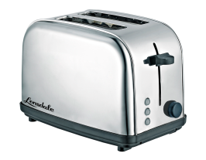
Electricity can produce light, sound, movement and heat.
Choose an item for each category draw a picture and write a sentence to tell us how electricity allows the object to do.
For example: Electric helps the toaster heat the bread.
________________________________
________________________________
________________________________
Light

Challenge – Can you spot an object that might produce more than one thing?
_____________________________________________________________________
________________________________
________________________________
________________________________
Movement
________________________________
________________________________
________________________________
Heat

________________________________
________________________________
________________________________
Sound

