Are all bridges the same?
During this sequence of lessons we will be exploring four types of bridges. These can all be seen in the pictures below. The arch bridge design is over 3000 years old and the cantilever bridge is used to cover long distances. The beam bridge is one of the simplest of designs, whereas as a suspension bridge uses chains, rope and cable to hold the bridge in place.
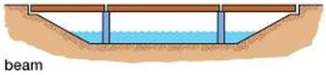

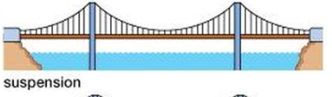
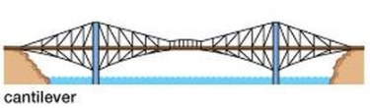

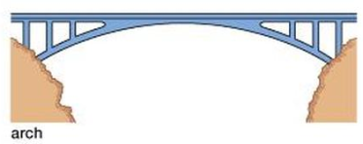
Famous bridges around the world:
Beam – Moselle viaduct, Germany
Suspension – Brooklyn bridge, USA
Cantilever – Forth bridge, Scotland
Arch – Sydney Harbour bridge, Australia
Key Vocabulary
Arch  Cantilever  Suspension  Beam | pillar  cable  abutment  suspension
Are all bridges the same?
During this sequence of lessons we will be exploring four types of bridges. These can all be seen in the pictures below. The arch bridge design is over 3000 years old and the cantilever bridge is used to cover long distances. The beam bridge is one of the simplest of designs, whereas as a suspension bridge uses chains, rope and cable to hold the bridge in place.

Famous bridges around the world:
Beam – Moselle viaduct, Germany
Suspension – Brooklyn bridge, USA
Cantilever – Forth bridge, Scotland
Arch – Sydney Harbour bridge, Australia
Key Vocabulary
Arch  Cantilever  Suspension  Beam | pillar  cable  abutment  suspension

Are all bridges the same?
During this sequence of lessons we will be exploring four types of bridges. These can all be seen in the pictures below. The arch bridge design is over 3000 years old and the cantilever bridge is used to cover long distances. The beam bridge is one of the simplest of designs, whereas as a suspension bridge uses chains, rope and cable to hold the bridge in place.

Famous bridges around the world:
Beam – Moselle viaduct, Germany
Suspension – Brooklyn bridge, USA
Cantilever – Forth bridge, Scotland
Arch – Sydney Harbour bridge, Australia
Key Vocabulary
Arch  Cantilever  Suspension  Beam | pillar  cable  abutment  suspension

Are all bridges the same?
During this sequence of lessons we will be exploring four types of bridges. These can all be seen in the pictures below. The arch bridge design is over 3000 years old and the cantilever bridge is used to cover long distances. The beam bridge is one of the simplest of designs, whereas as a suspension bridge uses chains, rope and cable to hold the bridge in place.

Famous bridges around the world:
Beam – Moselle viaduct, Germany
Suspension – Brooklyn bridge, USA
Cantilever – Forth bridge, Scotland
Arch – Sydney Harbour bridge, Australia
Key Vocabulary
Arch  Cantilever  Suspension  Beam | pillar  cable  abutment  suspension
Are all bridges the same?
During this sequence of lessons we will be exploring four types of bridges. These can all be seen in the pictures below. The arch bridge design is over 3000 years old and the cantilever bridge is used to cover long distances. The beam bridge is one of the simplest of designs, whereas as a suspension bridge uses chains, rope and cable to hold the bridge in place.

Famous bridges around the world:
Beam – Moselle viaduct, Germany
Suspension – Brooklyn bridge, USA
Cantilever – Forth bridge, Scotland
Arch – Sydney Harbour bridge, Australia
Key Vocabulary
Arch  Cantilever  Suspension  Beam | pillar  cable  abutment  suspension

