Reading extract and questions:
Lucky Rudi

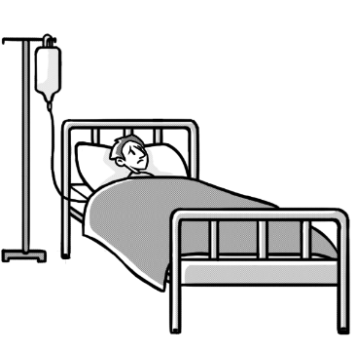
The nurse pulled the curtains around Tatiana’s bed and said she’d let her change in private. Mum folded her little girl’s clothes neatly and put them on the bedside chair while Tatiana struggled to put on the hospital gown. It was a weird, thin sheet with sleeves which tied up at the back rather than the front. Feeling shy, Tatiana slid under the covers.
“Have you got Rudi?” she asked.
“Of course,” replied Mum. “You can’t have an operation without your lucky rat!”
Mum fished Rudi out of the bag of books and games they had bought for Tatiana’s stay in hospital. For a soft toy, he was very lifelike. He was even a bit ragged and worse for wear, rather like a real rat. That didn’t bother Tatiana, however. She had loved him for years and he went everywhere with her.
Even so, she was worried what the other children on the ward might think. Was it ok for a grown-up girl of six to still have a cuddly toy? She tucked him out of sight, under her pillow, just in case.
The nurse poked her head through the curtains. “All done? Good. The trolley will be here soon to take you down for your operation.” This made Tatiana feel a bit wobbly. She turned on her side to look at Mum. Her hand slipped under her pillow and clutched Rudi.
Noticing her watery eyes, Mum held her other hand and smiled. “It’ll be over before you know it. I’ll be right here when you come back to the ward. Just think, you can start looking forward to not hurting all the time.” Tatiana smiled bravely and rubbed her eyes with her hand.
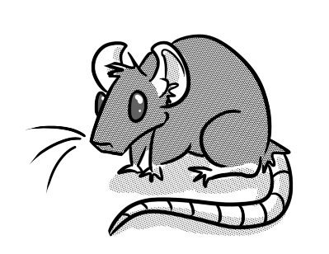
A jolly man appeared along with the nurse and a bed on wheels. Mum and the nurse helped Tatiana onto the bed. Then the nurse picked up Tatiana’s pillow.
“Eeeeeek!” screeched the nurse. “It’s a r-r-rat.” Everyone looked around. There was the nurse, holding Rudi by the tail and grinning broadly. “We don’t usually allow rats in the hospital,” she smiled, “but I think we can allow it … just this once. Perhaps he would like to ride along with you. You can help him to be brave.”

Questions for
Lucky Rudi
Day 2
Vocabulary
1. Look at the first paragraph. Find and copy a word that means strange.

_________________________________________________________________

2. … “Mum fished Rudi out” … This means that Mum … Tick one.

found Rudi with a net caught Rudi with a hook

let Rudi slip out of her hands pulled Rudi out

Identify key aspects
3. Why did Tatiana want Rudi with her in hospital?

_________________________________________________________________

4. Who came back with the nurse?

_________________________________________________________________

5. Why did the nurse say, “Eeeeeek!”?

_________________________________________________________________

Inference
6. How was Tatiana feeling when Mum held her hand? How do you know?

_________________________________________________________________

Sequence
7. Number the parts of the story from 1 to 4 to show the order in which they appear.

The nurse held Rudi by the tail.
The nurse told them the trolley would arrive soon.
Tatiana put Rudi under her pillow.
Tatiana changed into her hospital gown.

Predict
8. What would the nurse say if Tatiana asked whether she was scared of Rudi?

_______________________________________________________________________________

