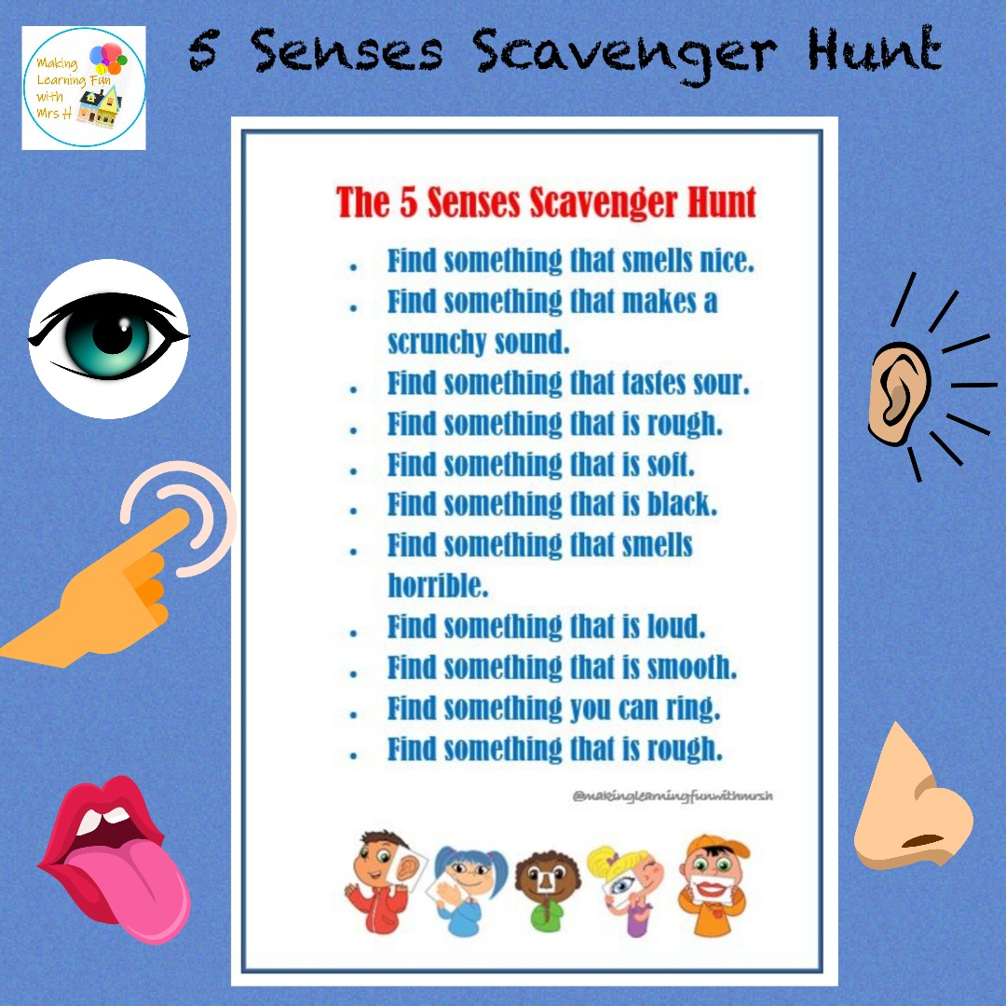
Indoor or outdoor, why not enjoy this 5 Senses Scavenger Hunt. A great opportunity to talk about what the 5 senses are and what it might be like if we lost one of them.
Have fun!

